 Newsletter

Winter/Spring 2018/2019

**Mission Statement**

**To provide quality support and end of life services to our clients and their loved ones, caregivers and the bereaved in Hope and its surrounding areas.**

#### Board of Directors 2019/2020

Pat Besse - Chair

Kathy Gordin - Vice Chair

Barbara Sharrers

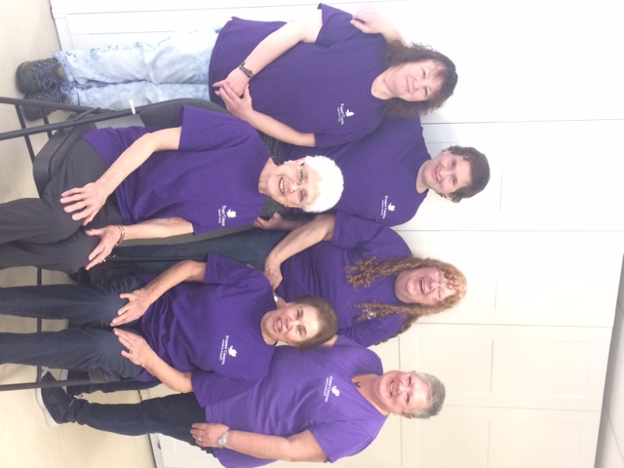

Judy Miller

Beverly Mason

Carol Chaulk

Brian McLean

**Staff**

Mary Norman

Hospice Coordinator/Secretary

Ken Hurley -Camp Skylark Director

**Mailing Address**

1275 -7th Avenue

Hope, British Columbia

V0X 1L4

Phone: 604-860-7713

Fax: 604-860-7709

info@frasercanyonhospice.org

[www.frasercanyonhospice.org](http://www.frasercanyonhospice.org)

Pictured above are some of our valued volunteers/Board Members… Back Row – L-R Pat, Brian, Kathy and Beverly and Front Row – L-R Carol and Ann **National Volunteer Day – was the appropriate day to host the Fraser Canyon Hospice Society –**

**Volunteer Appreciation Luncheon**

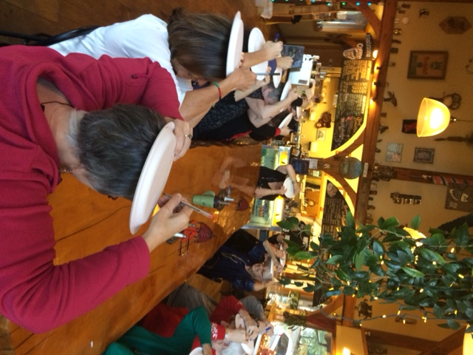

One of the few games played (pictured left), where shared at the volunteer appreciation Luncheon, on December 4th 2018. A total of 17 volunteers/staff attended. This year the event was held at the Owl Street Café. It was delicious food, and the hosts Jane, Thomas and Diane catered to our needs.

This was a token of thanks to all the dedicated volunteers for the hard work they have donated over the past year. Lots of fun was had, playing games, excellent food, and wonderful company.

November 27th Salli Rice, resident of Hope, donated a handmade quilt to Fraser Canyon Hospice Society, which will be raffled in the near future. Holding the quilt pictured L-R (Judy Miller and Carol Chaulk) both Board Members of FCHS   
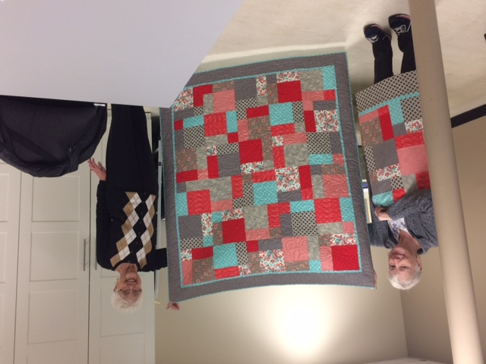

Fraser Health hosted their annual Health Fair on October 27th 2018. The Venue was held at the Hope Recreation Centre, thank you to Joy, Dianne, (Anna and Kitty pictured above) for assisting and answering questions of the good work Volunteers do throughout the year.

To learn more, contact the Hospice Office 604-860-7713 or [mary.norman@fraserhealth.ca](mailto:mary.norman@fraserhealth.ca)

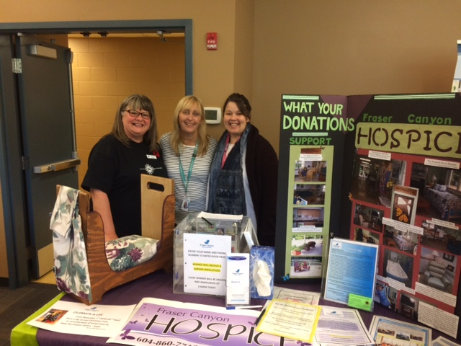

**Dates of upcoming Fundraising events**

April 20th 2019 Saturday - Meat Draw at Royal Canadian Legion BR#228

June 15th 2019 **Hot Dog Fundraiser** – Buy Low Foods 11am to 2:30

**Fraser Canyon Hospice Society Raffle** –***Tickets will be sold at various locations***.

Confirmed: Envision Foyer from 1pm to 5pm on the following dates

Monday **April 15th 2019**, Monday **May 27th 2019**, Thursday **July 18th, 2019**

FCHS - **Services**

**Please note all services listed below, need to be pre-registered with the Hospice Coordinator - Mary Norman 604-860-7713**

**Relaxing Group** –A one hour guided meditation session for Palliative clients, family caregivers, and the bereaved Every 4th Thursday of the Month, pre –registration is required.

**Basic Hospice Training –** will be held on Tuesday and Thursdays, commencing April 30th 2019 from 1pm to 4pm. **Pre-registration is required.** *Limited seats*

**Walking Group** – May 2019 to Fall - Open to Caregiver and Palliative and bereaved clients. Its purpose is to encourage self-care while connecting Clients with others in similar situations.

**Companioning** – visit to Palliative Client, and support for family/friends

**Vigil Services** – Client and family support during the last 72 hours of life, in the setting that is home to the client.

**Bereavement Support** – for Palliative Bereaved Caregiver, family and friends

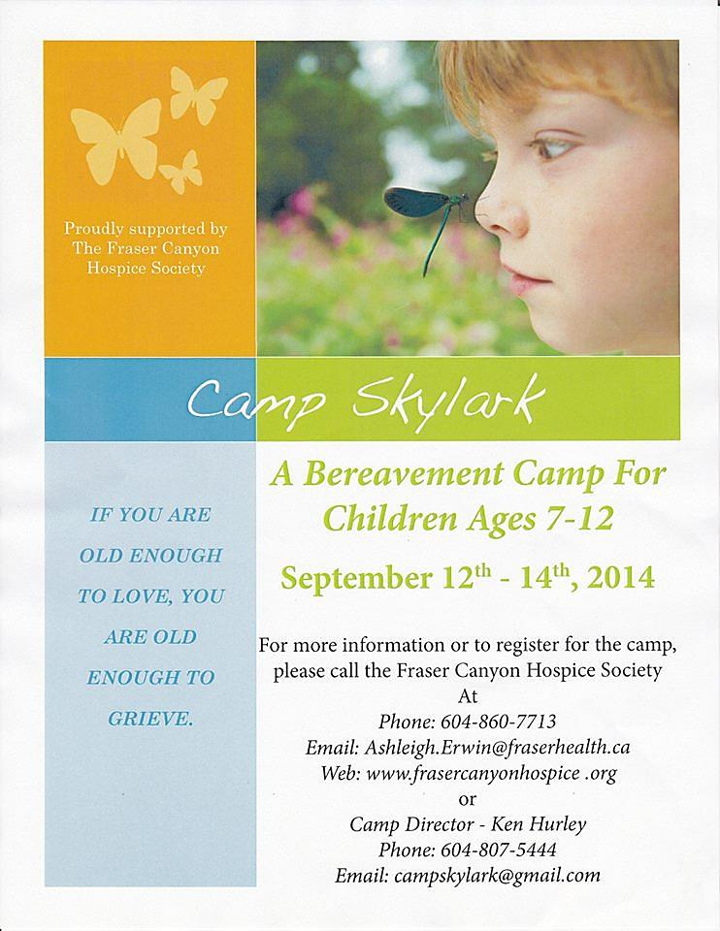**Camp Skylark Bereavement Camp - Children ages 7-12 years.** 2019 will host our 15th Camp Skylark Camp, scheduled for September 13,14 and 15th 2019. A Camp Director will be hired in May 2019, if you have someone who may benefit from this camp, or know of people who are interested in becoming a volunteer specific for this event, please contact the Hospice Office 604-860-7713 or email the Hospice Coordinator – [mary.norman@fraserhealth.ca](mailto:mary.norman@fraserhealth.ca)

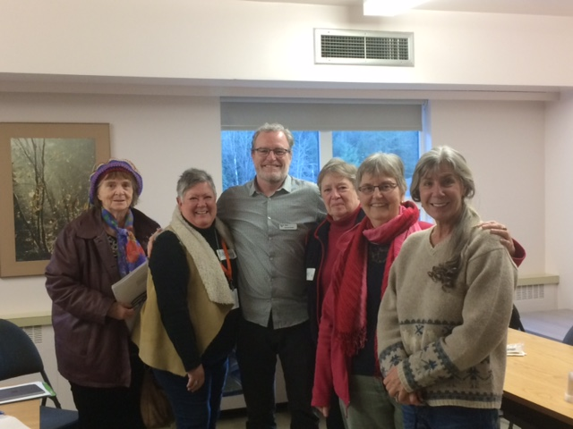**Spiritual Health Training – by Fraser Health** was held on January 21st and 28th 2019 by Don Cowie, Fraser Health – Spiritual Health Practitioner, Don facilitated the Spiritual Health Training to 5 Hospice Volunteers as pictured L-RTheresa, Beverly, (Don) Kathleen, Anna and Lore Lei

It was our 22nd annual “Celebrate a Life” Tree of Hope, which was placed in the Foyer of the Hope Recreation Centre for the month of December.

During 2018, there were a total of 310 tree tags placed on the tree, remembering the many loved ones who have passed on. Thank you to the volunteers who put the tree up, Beverly and Kathy and the FCRD for allowing the tree to be placed in the Foyer each year.

**2018 Celebrate-a-Life Tree**

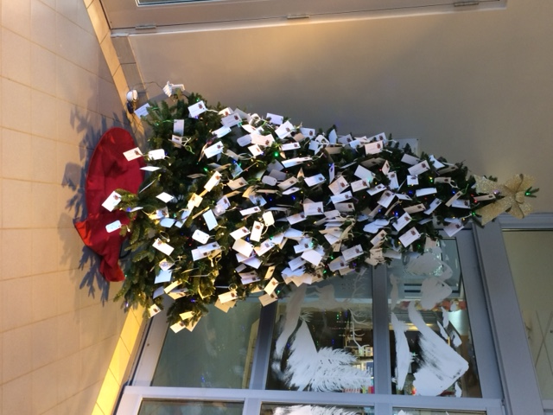

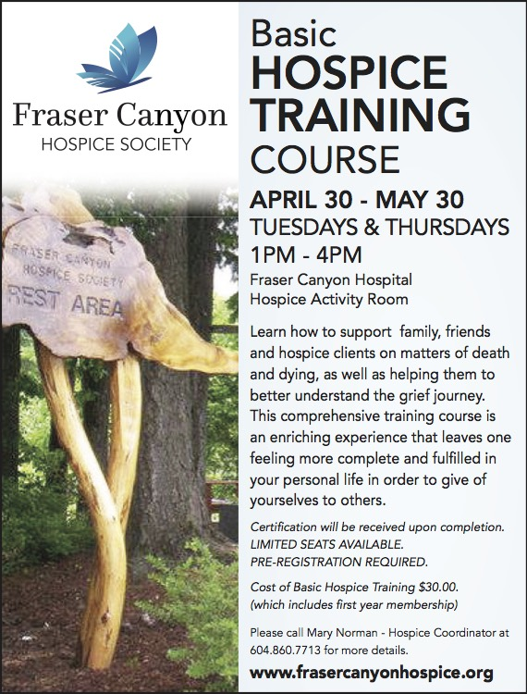 *Graphics created and curtesy of Black Press*

**UPCOMING RAFFLE TO SUPPORT FRASER CANYON HOSPICE SOCIETY**

**PRIZES AS LISTED BELOW:**

**1st  7 night accommodation at Whistler, BC. Condo – (Sleeps up to 6) - Week commencing September 22nd to 29th 2019  – value $2,500.00**

**2nd   Harrison Hot Springs Resort - overnight midweek stay for 2 people includes breakfast - value $350.00**

**3rd   Handmade - Lap Quilt – value $350.00**

**4th  Overnight Stay at Harrison Beach Hotel and $50.00 Gift Certificate for Black Forest = value $330.00**

**5th   Shell Gas Station –Gift Cards – value $300.00**

**6th   STIHL – Weed Wacker – value $250.00**

**7th Gift vouchers/Cards $50.00-Home Restaurant – 2 Hats-Coffee, $27.00 re Sharon’s Deli, 5 Booster Juice Smoothies Voucher, $20.00 – Hope Mountain Café Gift Card, Starbucks –Gift Bag, $50.00 Blue Moose Gift Card- total value of prizes $200.00**

**8th Gift Certificate for Brenner Automotive, Hope, $50.00 and Lordco $25.00 Gift Card and Gift Bag– value $90.00**

**9th Hamilton Beach Kettle – value $80.00**

**10th $80.00 Gift Certificates for Rolly’s Restaurant, Hope, BC. – value $80.00**

**Tickets $5.00 each**

**Winning Tickets Drawn:  Sunday, August 18th 2019 at 10:30am**

**Location of Draw – (Chain Saw Carving Event, Hope BC - Stage at Main Park-, District of Hope Offices 325 Wallace Street)**

(winners consent to release of their names by the licensee)

Minors are not permitted to buy or sell raffle tickets must be 19+ Only 1500 tickets printed