 Newsletter

SUMMER 2019

**Mission Statement**

**To provide quality support and end of life services to our clients and their loved ones, caregivers and the bereaved in Hope and its surrounding areas.**



#### Board of Directors 2019/2020

Pat Besse - Chair

Kathy Gordin - Vice Chair

Barbara Sharrers

Judy Miller

Beverly Mason

Carol Chaulk

Brian McLean

**Staff**

Mary Norman

Hospice Coordinator/Secretary

Ken Hurley -Camp Skylark Director

**Mailing Address**

1275 -7th Avenue

Hope, British Columbia

V0X 1L4

At our recent 2019 Camp Skylark, this year the camp had Artist, Freda Lombard who was the Art Therapist…she introduced and facilitated a group painting. This was a wonderful bonding experience for all, as everyone painted a tree and its shadow on this canvas and all Campers and Volunteers signed the back.

Phone: 604-860-7713

Fax: 604-860-7709

info@frasercanyonhospice.org

[www.frasercanyonhospice.org](http://www.frasercanyonhospice.org)

**PHOTO OF DONATED PILLOW CASES FROM SALLI RICE April 17, 2019**

**May 11th the 1st Health and Wellness Fair in Agassiz was held at 6660 Pioneer Ave Community Recreation and Cultural Centre**

**Photo of donated banner for Camp Skylark**

**Eagles Hall donations – Photo**

**BHT - COMMENCED APRIL 30TH TO May 30th 2019**

**Photo of flowers deck and gazebo**

**June 15th Hot Dog Sale – photo**

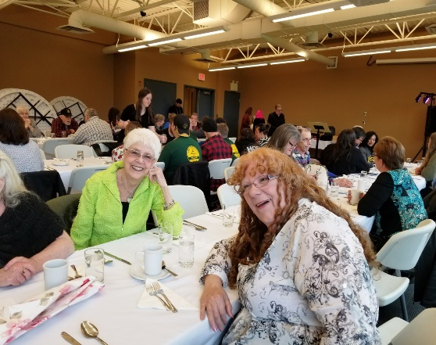

**Dates of upcoming Fundraising events**

April 20th 2019 Saturday - Meat Draw at Royal Canadian Legion BR#228

June 15th 2019 **Hot Dog Fundraiser** – Buy Low Foods 11am to 2:30

**Fraser Canyon Hospice Society Raffle** –***Tickets will be sold at various locations***.

Confirmed: Envision Foyer from 1pm to 5pm on the following dates

Monday **April 15th 2019**, Monday **May 27th 2019**, Thursday **July 18th, 2019**

FCHS - **Services**

**Please note all services listed below, need to be pre-registered with the Hospice Coordinator - Mary Norman 604-860-7713**

**Relaxing Group** –A one hour guided meditation session for Palliative clients, family caregivers, and the bereaved Every 4th Thursday of the Month, pre –registration is required.

**Basic Hospice Training –** will be held on Tuesday and Thursdays, commencing April 30th 2019 from 1pm to 4pm. **Pre-registration is required.** *Limited seats*

**Walking Group** – May 2019 to Fall - Open to Caregiver and Palliative and bereaved clients. Its purpose is to encourage self-care while connecting Clients with others in similar situations.

**Companioning** – visit to Palliative Client, and support for family/friends

**Vigil Services** – Client and family support during the last 72 hours of life, in the setting that is home to the client.

**Bereavement Support** – for Palliative Bereaved Caregiver, family and friends

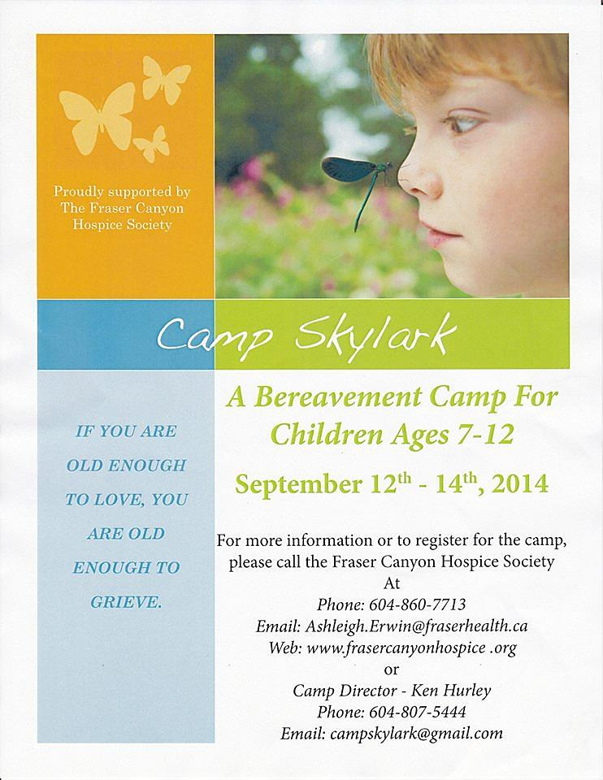**Camp Skylark Bereavement Camp - Children ages 7-12 years.** 2019 will host our 15th Camp Skylark Camp, scheduled for September 13,14 and 15th 2019. A Camp Director will be hired in May 2019, if you have someone who may benefit from this camp, or know of people who are interested in becoming a volunteer specific for this event, please contact the Hospice Office 604-860-7713 or email the Hospice Coordinator – [mary.norman@fraserhealth.ca](mailto:mary.norman@fraserhealth.ca)

*Graphics created and curtesy of Black Press*

RAFFLE DRAWN 2019 WORLD CLASS CHAIN CARVING COMPETITION AUGUST 18TH AT 10:30.

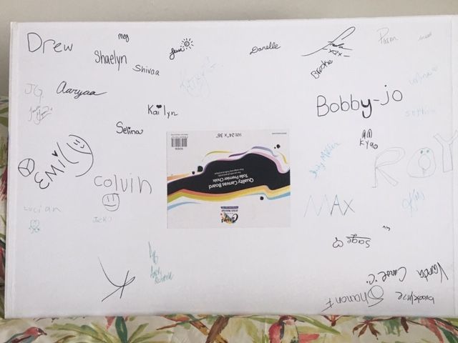

 Hi All

One of the highlights of camp this year was our resident Artist, Freda Lombard who introduced and facilitated a group painting.

This was a wonderful bonding experience for all as everyone painted a tree and its shadow on this canvas and we all signed the back.

I will get it framed and present it to the Hospice, I hope to have Freda there when we do. 